5th International Conference on Innovative Practices in Technology and Management (ICIPTM) 2026 at Amity University, Noida

Enhancing Stock Price Prediction: A Multi-Model Framework Integrating Technical Indicators and Sentiment Analysis

Adwaidh Prakasan Department of Computer Science and Engineering
Christ University
Bangalore, India adwaidhprakasan@gmail.com
Karthikeyan Harimoorthy Department of Computer Science and Engineering
Christ University
Bangalore, India karthikeyan.h@christuniversity.in
Ganesh Kumar R
Department of Computer Science and Engineering
Christ University
Bangalore, India ganesh.kumar@christuniversity.in

Abstract—This paper proposes a multi-model strategy that would improve the predictive power of stock prices by combining time-series analytics with external market indicators. The system allows five different base prediction methods; Long Short-Term Memory (LSTM), Enhanced Bidirectional LSTM (XLSTM), Support Vector Machine (SVM) which may use radial basis function (rbf), linear or polynomial (poly) kernels, Autoregressive integrated moving average (ARIMA), and Seasonal Autoregres- sive integrated moving average (SARIMA). A stacking procedure which uses linear regression as a meta-model together with a voting ensemble method is then employed to link these base models. The feature engineering is thorough, as it provides for general price and volume data, a battery of technical indicators (SMA10, SMA20, EMA 12, EMA 26, MACD elements, and
RSI14) and a general sentiment indicator (summarised financial news). Sentiment analysis is performed by a pipeline that is trained using RoBERTa and yields discrete numerical values (0 negative, 1 neutral, 2 positive). The model’s capability is very rigorously gauged by the conventional metrics Root Mean Squared Error (RMSE), Mean Absolute Error (MAE), Mean Absolute Percentage Error (MAPE), and Directional Accuracy (DA). The real-world results demonstrate that the ensemble method is very efficient where the stacking arrangement leads to the lowest total MAPE of 0.6027% MSFT and the highest directional Accuracy of 75.86% GOOGL, thus, providing a strong evidence for the effectiveness of the thorough integration of heterogeneous machine-learning, statistical, and sentiment- analysis methods to produce the most accurate financial forecasts.

Index Terms—ARIMA, Ensemble Learning, Financial Fore- casting, LSTM, Sentiment Analysis, Stock Price Prediction, Sup- port Vector Machine (SVM), Technical Indicators, Time Series Analysis, XLSTM

- Introduction
According to Mishra et al. [1], to a large extent, a particular country’s stock market acts as a replica of its economy. These markets are closely monitored by investors around the world who are interested in potential changes. Traditionally, market forces have been viewed as a contingent outcome of existing shocks. Therefore, predicting future trends has become the most important aspect of decision making. However, the
market structure has changed dramatically. It no longer relies on crude statistical tests, but on more detailed calculations. LSTM models in such environments have become a tool to approach price prediction in various markets such as the United States, India, and China, as noted by Ji et al. and Chen et al. [2], [3]. The industry is moving towards an integrated approach that uses multidimensional forecasting, including sentiment analysis of social media sites using platforms such as Twitter and Stocktwits, sentiment strength, and industry- specific financial metrics, found by Mishra et al. [4]. The main reason why inventory forecasting methods need to be continuously improved is the need to ensure financial stability and enable any profit during turbulent times [2]. Obtaining certain information can significantly increase the level of risky behavior of investors and push them into uncharted trading territory. This is especially true when the traditional financial context is replaced by a live, high-speed execution of public sentiment broadcast over the Internet [4].
Several empirical studies, by Milovidov [5] and Saravanos and Kanavos [6], have shown that national markets, such as the S&P 500, are primarily driven by market sentiment and are highly influenced by social media activity and search engine trends. Studies by Carosia et al. [7] and Ballesteros and Miranda [8] show that these qualitative human factors provide researchers with opportunities to improve technical metrics and deep learning models. This helps to counter investment risks, improve return on investment (ROI), and create more specific portfolio management elements.
Hotasi and Satya [9] and Ojha and Saxena [10] indicate that the stock market is one of the most difficult areas to predict accurately. Industry trends are neither completely linear nor completely chaotic, as the market is always in a slowly devel- oping transition process. As noted by Bi et al. [11], the noise produced by the daily news cycle can be very intimidating. Common indicators are often much less correlated with short- term index movements than technical indicators. Furthermore, Miralles-Quiro´s et al. [12], and Zakamulin and Giner [13], shows that the temporal privilege of technical models and

979-8-3195-4328-8/26/$31.00 ©2026 IEEE

the application of the so-called size effect law mean that algorithms for small-cap stocks cannot be applied to large-cap stocks [12], [13]. In markets such as Brazil and Indonesia, the situation is very complex. Information in these areas can be limited and volatility movements tend to differ from those seen in established Western markets [9], [12]. Zatwarnicki et al. [14] said that, individual markets such as cryptocurrencies are unregulated. This is why some technical predictors are too risky, and only more powerful and proven algorithmic models can provide a solution.
The rest of the article is organized as follows. Section II reviews the literature on the main forecasting methods such as technical indicators, sentiment analysis, and hybrid or ensem- ble forecasting. Section III presents the proposed methodology and framework, which describes the hybrid architecture and data collection, as well as five heterogeneous models (ARIMA, SARIMA, SVM, LSTM, and XLSTM). The fourth (IV) part details the implementation and experimental setup, including a description of the programming tools, dataset characteristics, and model hyperparameters. Section V presents results and discussion, comparing the performance of individual and en- semble models and showing that the latter is better. The final and sixth parts focus on future work and potential advances in feature engineering, NLP models, and advanced ensemble meta-learners.
- Literature Review
Stock market trend prediction remains a challenging task as financial time series data continue to be characterized by high volatility, non-linearity, and sometimes chaotic behavior [1]. The recent papers depict three major approaches for dealing with this issue: the employment of technical indicators, the use of sentiment analysis, and the implementation of hybrid or ensemble, based forecasting models.
- Technical Indicator-Based Prediction
The conventional forecasting is based on the historical price and mathematical indicators to detect the trends. Mishra et al. [1] initiated this investigation by making a comparison between Statistical and Regression analysis and advanced models, which observed that the market movements were deeply anchored in the past changing movements. We can hear this resonance in the article by Zakamulin and Giner [13], which gives the theoretical results demonstrating that even though Momentum (MOM) and Moving Average (MA) rules are similar, MA rules are stronger in indicating the direction of the price in the future. Specific applications of these indicators include:
  - Moving Averages (MA): Ojha and Saxena [10] used Simple (SMA) (1) and Exponential (EMA) (2) Moving averages on the TCS and Apple and Miralles-Quiro´s et al. [12] established that moving averages rules in the Brazilian market do better in small-cap indices than in large firms.
  - Momentum Oscillators: Zatwarnicki et al. [14] re- searched the Relative Strength Index (RSI) (3) indicator
within the cryptocurrency market and arrived at the conclusion that though RSI indicators are associated with high risks, algorithmic backtesting can give an edge over the so-called buy and hold strategies.
  - Deep Learning as Technicals: Li and Bastos [15] performed a systematic review and determined that 73.5% of deep learning works today use LSTM as a technical analysis and only 35.3% of them analyze real profitability.

- Sentiment Analysis in Finance
The emergence of social media has brought qualitative data in the quantitative model. According to Mishra et al. [4], aggregate sentiments on sites such as Twitter (now X) and StockTwits may be used to move stock prices. This was extended by Milovidov [5], who did Google search queries in Russia and the US to get sentiment indices and discovered that they correlated well with the S&P500 and IMOEX.
The history of development of sentiment methodologies entails:
  - Source Diversity: Scholars are no longer dealing with general everyday news in the world [10] but with partic- ular information on microblogging [16], [17].
  - Psychological Metrics: The articles by Mishra et al.
[4] and Saravanos and Kanavos [6] presented such new characteristics as the ”Emotional Intensity Analysis” and the Fear Greed Index, and Saravanos and Kanavos [6] also considered the role of the so-called tweet diffusion and the prominence of users.
  - Advanced NLP: Mishev et al. [18] compared the process of transitioning between simple lexicons to NLP Trans- formers and has shown that the contextual embeddings are more efficient and efficient than simple ones, even when small datasets are used.
  - International Opinions: It has been confirmed through studies that sentiment affects the various markets such as China [19], Indonesia [9] and the US [11].

- Hybrid or Ensemble Forecasting Models
Hybridization tries to allow the combination of the memory of the time provided by deep learning and the understanding in the context of sentiment analysis.
  - LSTM Dominance: Ji et al. [2] and Chen et al. [3] indicated the strength of LSTM in the Indian market, the American market, and the Chinese market with Chen documenting an increase of accuracy by 14.3% to 27.2%.
  - Feature Fusion: Both Carosia et al. [7] and Arauco Ballesteros et al. indicated that historical prices, technical indicators, and news outperform in prediction error and Return-on-Investment (ROI) when used together (rather than alone). The Indonesia Stock Exchange was handled by Hotasi and Satya [9] using a hybrid Naive Bayes and KNN technique.
  - Ensemble Techniques: Owen and Oktariani [16] added CNN, MLP, and LSTM to Ensemble Techniques to ensure a 25% improvement in performance. On the same note,

Bi et al. [11] employed a majority vote of Random Forest, SVM, and Naive Bayes to increase accuracy.
  - Dynamic Adaptation: Peivandizadeh et al. [20] proposed Transductive LSTM (TLSTM) to manage both class imbalance in sentiment and time dynamics and Mehta et al. [21] and Gite et al. [22] trained news headlines on top of LSTM to generate more clear and more subtle predictions.
- Gaps Remaining in the Literature
While different research domains are well fleshed out, TIs represent one of the most potent features, SA achieves very high accuracy with the use of transformers, and ensemble models are very stable. The main residual gap, however, is about deeply embedding advanced features across several complex models for a single prediction system [7].
To be exact, those remaining gaps that your program is intended to close are:
- Lack of Comprehensive Feature Integration in Ad- vanced Models: The number of investigations that en- tirely merge comprehensive feature sets such as highly advanced sentiment embeddings (e.g., from transformers or highly accurate lexicon, based scores) as well as very complex technical indicators (beyond basic OHLCV and volume) plus fundamental indicators into one single input layer for prediction is minimal. Most of the presently pro- posed hybrid models merely consider a simple sentiment polarity that is somewhat integrated with traditional TIs [7].
- Insufficient Integration of Advanced Features with Ensemble/Stacked Models: On the one hand, ensem- ble models (like random forest, XGBoost, or stacking classifiers) are already implemented as forecasters; on the other hand, they still often employ less enriched or standardized input features. It is pointed to the absence of work that deeply and extensively extracts features (e.g., by simultaneously integrating deep learning, derived sen- timent features together with comprehensive TIs) with the sole purpose of a robust stacked or ensemble forecasting model be the most appropriate one to be trained. The main novelty is combining these components [7].
- Methodology / Proposed Framework
The proposed study, “Enhancing Stock Price Prediction: A Multi-Model Framework Integrating Technical Indicators

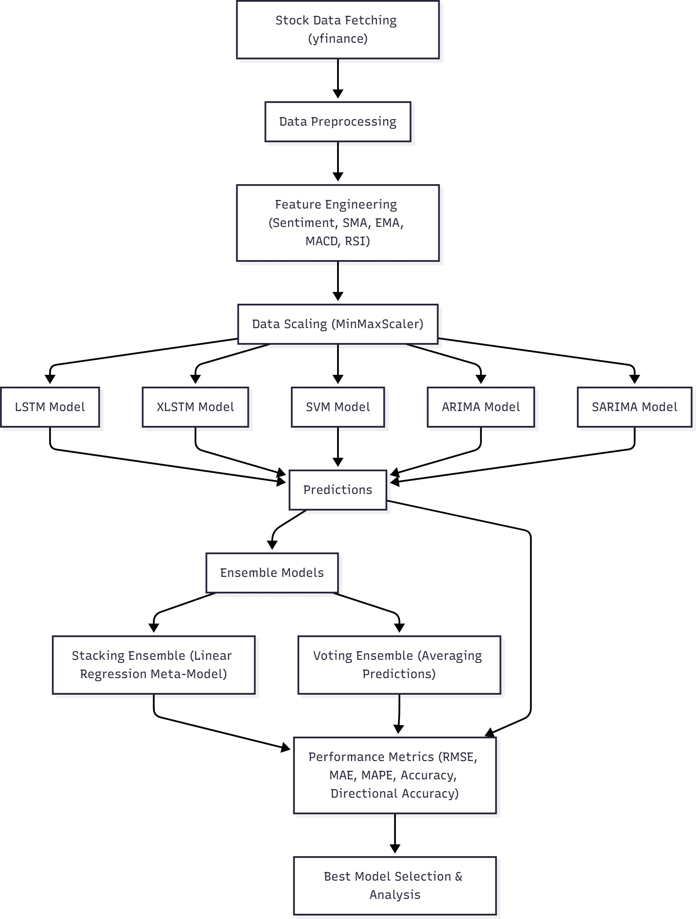
Fig. 1. System Architecture for Stock Price Prediction
closing prices P_{t}, the framework defines a rolling window of length n to predict prices Pˆt+h over a forecast horizon h:

Pˆt+h = f (P_{t−n+1}, P_{t−n+2}, . . . , P_{t})
To ensure adequate model training, a configurable historical window (30–120 days) is collected, followed by a user-defined prediction horizon (15–45 days).

- Feature Engineering
To capture trend and momentum characteristics, the frame- work extracts technical indicators:

Simple Moving Average (SMA):
n−1
Σ
1

and Sentiment Analysis”, introduces a hybrid architecture combining statistical, machine learning, and deep learning
SMA_{t} =
n

i=0
P_{t−i} (1)

paradigms. The approach integrates technical indicators and

Exponential Moving Average (EMA):

sentiment analysis to enhance predictive performance and directional reliability. The complete pipeline is depicted in
EMA_{t}
= αP_{t}
+ (1 − α)EMA

t−1
2
, α =
n + 1
(2)

Fig. 1. • Relative Strength Index (RSI):

A. Data Acquisition
Historical stock data were retrieved from Yahoo Finance
RSI_{t}
100
= 100 − Avg Gain
1 +
Avg Loss
(3)

using the yfinance API. Each record includes OHLCV values (Open, High, Low, Close, Volume). Given a time series of

MACD Line (Difference between two EMAs):
MACD_{t} = EMA₁₂(P_{t}) − EMA₂₆(P_{t}) (4)

MACD Signal Line (Smoothed MACD, often a 9-day EMA of MACD):
MACDs_{t} = EMA₉(MACD_{t}) (5)

MACD Histogram (Difference between MACD Line and Signal Line):
MACDh_{t} = MACD_{t} − MACDs_{t} (6)
All features are normalized via Min–Max scaling to ensure consistent training convergence. To prevent data leakage and look-ahead bias, initially the dataset is split into training data and testing data. Scaler fittransform is fitted on training data and Scaler transform is fitted on testing data exclusively.

X′ = X − X_{min}
Xmax − Xmin

- Sentiment Integration

Investor sentiment is extracted from financial news and social media using NLP models. For each trading day t, the aggregated sentiment score S_{t} is computed as:
  - Long Short-Term Memory (LSTM): Captures sequen- tial dependencies with gated memory (see Fig. 2):
f_{t} = σ(W_{f} [h_{t−1}, x_{t}] + b_{f} )
i_{t} = σ(W_{i}[h_{t−1}, x_{t}] + b_{i})
C˜t = tanh(W_{C}[h_{t−1}, x_{t}] + b_{C})
C_{t} = f_{t} ∗ C_{t−1} + i_{t} ∗ C˜t h_{t} = o_{t} ∗ tanh(C_{t})

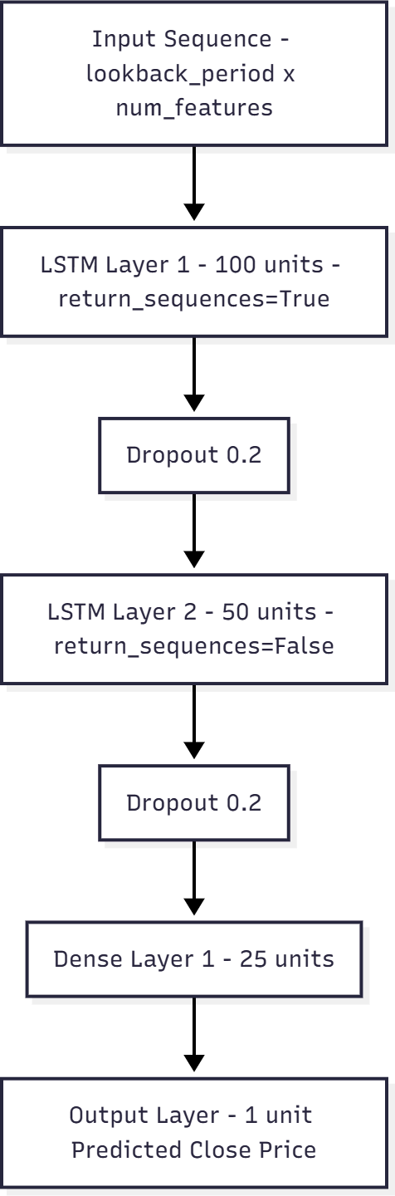
S = 1 Σ s
N_{t}
Nt
t
i
i=1

where s_{i} ∈ [−1, 1] represents the polarity of the ith news item, and N_{t} is the total number of items on day t. Incor- porating S_{t} as an additional feature allows the framework to capture market psychology, complementing traditional price-
based indicators.
If there is a lack of news coverage for a particular day, a two-step fallback strategy is use. First, if the API retrieves zero articles for a given date t, the query window is expanded to include the previous day (t−1). Second, if no relevant news is
found within this extended window, a neutral sentiment score
of 1.0 is given.

- Model Development
Five heterogeneous predictive models are employed:

ARIMA (AutoRegressive Integrated Moving Aver-

Fig. 2. LSTM Model Architecture for Stock Price Prediction
  - Enhanced LSTM (xLSTM): Utilizes bidirectional and stacked layers:
h_{t} = [h→; h←]

age): Captures linear temporal dependencies: ^{t} ^{t}

ϕ(B)(1 − B)^{d}P_{t} = θ(B)ε_{t}
    - SARIMA (Seasonal ARIMA): Extends ARIMA for seasonality:
Φ(B_{s})ϕ(B)(1 − B)^{d}(1 − B_{s})^{D}P_{t} = Θ(B_{s})θ(B)ε_{t}
    - Support Vector Regression (SVM): Performs nonlinear regression:
n
All neural models are trained using the Adam optimizer with mean squared error (MSE) loss.
- Performance Evaluation
Models are evaluated using both statistical and practical metrics:

Root Mean Squared Error (RMSE):
,u N

f (x) = w^{T} ϕ(x) + b,
1 2 Σ ξ
RMSE = u, 1 Σ(Pˆ − P )2 (7)

min w
2
+ C _{i}
i=1
N t t t=1

Mean Absolute Error (MAE):
MAE = 1 Σ |Pˆ − P | (8)
N
N t t
t=1
predictiondays (D_{pred}), a minimum training buffer (50 days), and days lost during the calculation of Technical Indicators (33 days).
– TotalDaysNeeded = (L + 50) + D_{pred} + 33

  - Mean Absolute Percentage Error (MAPE): • Features: The final dataset used for training consists of

100 Σ
N
Pˆ − P
14 features (dimensions). These include the raw OHLCV

MAPE =
N
t t
t=1 Pt
(9)
data, the calculated sentiment score, and 8 technical indicators:

  - Directional Accuracy (DA): Evaluates trading utility: – Open, High, Low, Close, Volume.

N
1 Σ
DA =
N
1 (P_{t+1} − P_{t})(Pˆt+1 − P_{t}) > 0
(10)
- Sentiment.
- SMA10, SMA20, EMA12, EMA26,

t=1
- Implementation / Experimental Setup
- Programming Tools
The framework is built upon a robust stack of Python libraries spanning deep learning, machine learning, time series analysis, and web development:
  - Core Languages and Environment: Python. The appli- cation is presented using Streamlit.

Deep Learning/Neural Networks:
    - TensorFlow/Keras is used for building and training the LSTM and XLSTM models.
    - Specific modules include Sequential, LSTM, Dense, Dropout, and Bidirectional layers, optimized using the Adam optimizer.
  - Machine Learning/Ensemble: Scikit-learn (sklearn) is used for standard ML models and ensemble meta- learners, including MinMaxScaler, SVR (Support Vector Regressor), and LinearRegression.
  - Time Series Analysis: Statsmodels (SARIMAX, ARIMA) and pmdarima (pm.autoarima) handle the traditional time series components.

Data Handling and Feature Engineering:
    - pandas and numpy are used for data manipulation.
    - yfinance (yf) fetches historical stock data.
    - pandasta (ta) calculates the technical indicators.

External Data Integration (Sentiment):
    - Finnhub is used as the client for fetching company news summaries via API.
    - Hugging Face Transformers (specifically the pipeline tool) utilizes the pre-trained model cardiffnlp/twitter- roberta-base-sentiment-latest for sentiment scoring.
    - The system uses pickle for caching sentiment results and the dotenv library for handling API keys.
- Dataset Details
  - Tickers: The models are tested on a selection of popular stocks chosen by the user via a dropdown menu, including AAPL, MSFT, GOOGL, AMZN, TSLA, NVDA, META, JPM, JNJ, and V.
  - Time Span and Size: The amount of historical data fetched is dynamic, calculated based on user inputs for prediction and lookback.
    - The total number of trading days requested (to- taldaystofetch) includes the lookbackperiod (L),
MACD12269, MACDh12269,
MACDs12269, and RSI14.
- Train/Test Split
The data is split sequentially for time series prediction.
- Preparation: After fetching, calculating features, and dropping initial NaN rows, the data is sliced. The final dataset must meet a minimum length requirement: look- backperiod + predictiondays + 50 minimum training samples.
- Training Data Length: trainingdatalen is defined as the total length of the cleaned data minus the predic- tiondays.
- Training Set: Used for fitting models.
- Testing Set: Used for prediction. It starts look- backperiod days prior to the end of the training set to ensure full sequences are available for the first prediction day.
- Target Data: The actualprices used for evaluation cor- respond to the ’Close’ prices of the days within the prediction window.
- Leakage Prevention: To prevent look-ahead bias, the se- quence generation process ensures that the input window for predicting time t only contains data from t − L to
t − 1. The target P_{t} and any future data P_{t+1} are never
included in the input features.
Hyperparameters
Key parameters are configurable by the user via the Stream- lit interface, as detailed in Table I:
- System Specifications and Constraints
The implementation includes features designed to manage system load and external API constraints:
  - Caching: The application utilizes Streamlit caching to store fetched data and the large sentiment analysis pipeline, improving execution speed and reducing redun- dant loads.
  - API Rate Limiting: A specific RateLimiter class is implemented for the sentiment retrieval process, setting a maximum of 55 calls per 60 seconds to comply with external API limits.
  - Sentiment Caching: Sentiment scores are saved locally using pickle files (sentimentcache directory) to avoid

TABLE I
Model Hyperparameters and Configurations

Parameter | Model(s) Affected | Options/Default Value
Lookback Period (L) | LSTM, XLSTM,  SVM | 30, 90 (default), 120  days
Prediction Days  (Dpred) | All Models,  Evaluation | 15, 30 (default), 45 days
Training Epochs | LSTM, XLSTM | Range 20 to 100, default  50
Batch Size | LSTM, XLSTM | 16, 32 (default), 64
SVM Kernel | SVM (SVR) | ”rbf” (default), ”linear”,  ”poly”
ARIMA/SARIMA  Order | ARIMA, SARIMA | Can be Auto-selected  (pm.auto arima) or man- ually defined (p: 0-5, d: 0-2, q: 0-5)
SARIMA Seasonal  Period (m) | SARIMA | Range 5 to 30, default 7
LSTM Architecture | LSTM | 2 layers (100 units, 50  units), Dropout (0.2), Adam optimizer (LR 0.001), MSE loss
XLSTM Architecture | XLSTM | 3 layers (Bidirectional  128 units, Bidirectional  64 units, LSTM 32 units), Dropout (0.3/0.2), Adam optimizer (LR 0.0005), MSE loss

making repeated API or heavy model inference calls for the same symbol and date.
  - Data Validation: Extensive checks are performed to ensure sufficient data remains after cleaning and feature calculation to prevent model failure.
  - Error Handling: Model training loops are wrapped in try-except blocks, allowing the process to continue if one model (e.g., ARIMA or a complex deep learning model) fails to train or predict, ensuring the ensemble phase can still proceed with the remaining valid models.
- Results and Discussion
This section presents the performance metrics of the indi- vidual and ensemble models, highlights the superior predictive capability of the ensemble methods, and discusses the role of feature engineering, including the integration of financial news sentiment.
- Model Performance Comparison (RMSE, MAE, MAPE, and DA)
The study utilized seven distinct models: LSTM, XLSTM (Enhanced Bidirectional LSTM), SVM, ARIMA, SARIMA, and two ensemble approaches (Stacking and Voting). Model performance was evaluated using standard metrics, including Root Mean Squared Error (RMSE), Mean Absolute Error (MAE), Mean Absolute Percentage Error (MAPE), and Di- rectional Accuracy (DA). The models were trained and tested on data enriched with numerous technical analysis features (SMAs, EMA, MACD, RSI) and a calculated sentiment score.
- Highlighting Best-Performing Model(s)
The performance comparison demonstrates that Ensemble Models, particularly Stacking, consistently achieved superior
TABLE II
Performance Metrics for GOOGL Stock

Model | RMSE | MAE | MAPE | Accuracy  (%) | Directional  Accuracy (%)
LSTM | 18.92 | 16.72 | 6.75 | 93.25 | 51.72
XLSTM | 7.05 | 6.13 | 2.49 | 97.51 | 51.72
SVM | 31.55 | 30.60 | 12.27 | 87.73 | 48.28
ARIMA | 34.08 | 28.84 | 11.61 | 88.39 | 51.72
SARIMA | 17.47 | 15.43 | 6.22 | 93.78 | 51.72
Stacking | 2.48 | 1.86 | 0.75 | 99.25 | 75.86
Voting | 10.32 | 9.38 | 3.78 | 96.22 | 51.72

TABLE III
Performance Metrics for JNJ Stock

Model | RMSE | MAE | MAPE | Accuracy  (%) | Directional  Accuracy (%)
LSTM | 7.76 | 6.67 | 3.53 | 96.47 | 51.72
XLSTM | 10.77 | 8.99 | 4.74 | 95.26 | 48.28
SVM | 17.08 | 14.80 | 7.82 | 92.18 | 34.48
ARIMA | 9.97 | 8.41 | 4.44 | 95.56 | 34.48
SARIMA | 9.97 | 8.41 | 4.44 | 95.56 | 34.48
Stacking | 1.61 | 1.32 | 0.72 | 99.28 | 68.97
Voting | 11.02 | 9.22 | 4.86 | 95.14 | 48.28

results compared to the individual base models (LSTM, XL- STM, SVM, ARIMA, SARIMA). The Stacking ensemble model combines the predictions of the base models and uses a meta-model (Linear Regression) to optimize the final forecast.
- Lowest Error Metrics: The Stacking model generally recorded the lowest RMSE, MAE, and MAPE across almost all stocks analyzed in the sources.
  - For GOOGL, Stacking achieved a remarkable MAPE of 0.75% (see Table II).
  - For MSFT, Stacking achieved the lowest MAPE at 0.60% (see Table IV).
  - For JNJ, Stacking achieved a MAPE of 0.72% (see Table III).
The framework uses a “one-step-ahead” rolling forecast (walk-forward validation). The model predicts the price P_{t+1} using the real data up to time t. Unlike recursive forecasting over a long time, where error accumulate, this method re-calibrates the model with recent actual data at each step.
- Highest Directional Accuracy (DA): While the best model recommendation is based on optimizing both Directional Accuracy and overall Accuracy, Stacking
TABLE IV
Performance Metrics for MSFT Stock

Model | RMSE | MAE | MAPE | Accuracy  (%) | Directional  Accuracy (%)
LSTM | 10.19 | 8.86 | 1.71 | 98.29 | 55.17
XLSTM | 27.27 | 26.76 | 5.18 | 94.82 | 55.17
SVM | 5.84 | 4.57 | 0.88 | 99.12 | 55.17
ARIMA | 11.05 | 9.34 | 1.81 | 98.19 | 51.72
SARIMA | 11.05 | 9.34 | 1.81 | 98.19 | 51.72
Stacking | 4.25 | 3.11 | 0.60 | 99.40 | 62.07
Voting | 6.36 | 4.96 | 0.96 | 99.04 | 55.17

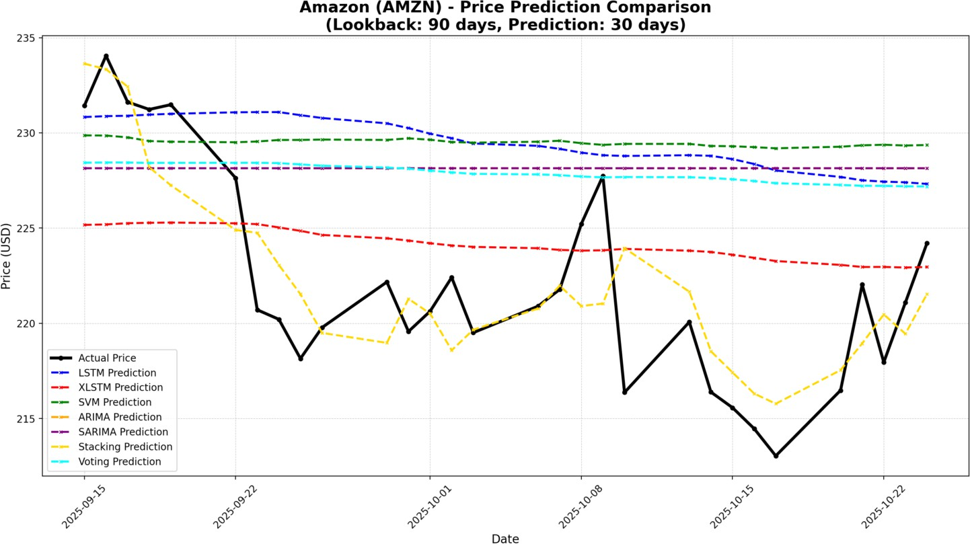

Fig. 3. Predicted vs. Actual Prices for AMZN
achieved the highest DA in key instances:
  - In GOOGL, Stacking achieved a DA of 75.86%.
  - In MSFT, Stacking achieved a DA of 62.07%.
  - For the stock V, Stacking also achieved the highest DA at 65.52%.
When recommending the best model, the system prioritizes the model with the highest Directional Accuracy, followed by overall Accuracy. Based on the comprehensive evaluation, the Stacking Ensemble often emerges as the Best Performing Model.
- Discussion of Feature Engineering
  - Effect of Adding Sentiment Features vs. Technical-Only: The models employed in this analysis utilize a comprehensive set of features, including five standard price/volume fea- tures, nine technical indicators (SMA10, SMA20, EMA12, EMA26, MACD components, RSI14), and a crucial Senti- ment feature.
    - Sentiment Feature Integration: The Sentiment feature is calculated by accessing financial news summaries for the stock on specific dates, processing these summaries through a pre-trained RoBERTa-based sentiment analysis pipeline, and assigning a numerical score (0 for nega- tive, 1 for neutral, 2 for positive) based on the average sentiment of relevant articles. This feature is integrated directly into the input data used by sequential models (LSTM, XLSTM) and SVM.
    - Quantitative Comparison Limitation: The provided sources confirm that all evaluated models incorporate the Sentiment feature alongside technical indicators. How- ever, the sources do not include a comparison table or specific analysis detailing the performance difference be- tween models trained with the full feature set (Technical
+ Sentiment) and models trained solely on technical features. Therefore, a direct quantitative discussion on the isolated effect of adding sentiment features cannot be conducted using the provided data.
- Visualization of Predicted vs. Actual Prices
A significant aspect of the findings is the qualitative compar- ison of the forecasts with the real prices during the evaluation
period (for example, the last 30 prediction days). The visual- ization plots the time series data comparing the Actual Price and the predictions generated by each model.
- Actual Price: Plotted as a solid black line with circular markers (marker=’o’).
- Predicted Prices: Colored dashed lines with ’x’ mark- ers for each individual model (LSTM, XLSTM, SVM, ARIMA, SARIMA) and ensemble method (Stacking, Voting) are plotted.
- Future Works
Based on the current framework, which successfully uti- lizes multiple base models (LSTM, XLSTM, SVM, ARIMA, SARIMA) and ensemble techniques (Stacking and Voting), several areas are identified for future research and enhance- ment to further improve prediction accuracy and robustness.
- Deepening Feature Engineering and Analysis
The current model mainly features the use of sentiment derived from financial news summaries; the analysis being done by a pre-trained RoBERTa-based pipeline. Future works should emphasize on refining the integration of this feature:
  - Quantitative Sentiment Impact Study: Although the sentiment is integrated, there is a need for a particular quantitative analysis that elaborates on the comparison of performance metrics (RMSE, DA, MAPE) of models which are trained with the full feature set (Technical + Sentiment) and models that are trained only on technical features. The analysis will actually measure the value added by the NLP feature.
  - Expanding Sentiment Data Sources: The method that is currently employed depends mainly on news summaries that are obtained through the Finnhub client. This restricts the analysis to at most ten articles per day. Therefore, a future study can create the sentiment score from a variety of sources such as the social media (e.g., Twitter data is not supported by the current sources), earnings call transcripts, or other financial reporting APIs so as to have a more comprehensive and multi-dimensional sentiment score.
  - NLP Model Refinement: A general sentiment model (cardiffnlp/twitter-roberta-base-sentiment-latest) is being used in the current implementation. Fine-tuning this model specifically on stock market or financial news cor- puses to better recognize industry-specific language and nuance, therefore potentially increasing the correctness of the 0, 1, or 2 score (negative, neutral, positive) could be a future project.
- Advanced Model Architecture and Ensemble Techniques
Although the Stacking Ensemble demonstrated superior performance in the current study (e.g., MAPE of 0.60% for MSFT and DA of 75.86% for GOOGL), refinement of the predictive architecture remains an area for growth:
  - Complex Ensemble Meta-Learners: The current Stack- ing implementation uses Linear Regression as the meta- model. Future research should explore replacing this

simple meta-learner with more complex, non-linear ma- chine learning algorithms (such as Random Forest, Gra- dient Boosting Machines, or a small Neural Network) to capture non-linear interactions between the predictions of the base models (LSTM, XLSTM, SVM, ARIMA, SARIMA).
  - Exploring Attention Mechanisms: The current deep learning models are based on standard LSTM and Bidi- rectional LSTM (XLSTM) architectures. Future iterations could investigate the use of Transformer or Attention- based neural networks, which are often better suited for modeling long-term dependencies in sequential data compared to traditional LSTMs.
- Automated Optimization and Parameter Tuning
The current implementation relies on manually selected or fixed ranges for key parameters:
  - Hyperparameter Optimization: Implementing auto- mated search techniques (like Grid Search or Bayesian Optimization) for critical parameters would ensure opti- mal performance. These parameters include:
    - The neural network hyper-parameters: Epochs (cur- rently a slider between 20 and 100), Batch Size (op- tions 16, 32, 64), and Dropout rates.
    - The SVM parameters (C and epsilon) beyond the fixed kernel selection (’rbf’, ’linear’, ’poly’).
    - The Lookback Period (currently fixed options of 30, 90, 120 days).
  - Dynamic Feature Selection: The current approach uses a fixed set of technical indicators. Future research could incorporate techniques to dynamically select the most relevant technical indicators for a specific stock or market condition, potentially enhancing the predictive power of the base models.
References
- A. Mishra, R. Singh, A. Agrawal, P. K. Arya, and A. Sharma, “Prediction of Exact Price of Stock and Direction of Stock Market Using Statistical and LSTM Model,” pp. 981–985, Jul. 2024, doi: 10.1109/AIARS63200.2024.00184.
- S. Ji et al., “Study of Stock Price Trends for Indian Share Market vs American Share Market Using LSTM,” pp. 1–5, Aug. 2024, doi: 10.1109/ACET61898.2024.10730548.
- K. Chen, Y. Zhou, and F. Dai, “A LSTM-based method for stock returns prediction: A case study of China stock market,” in Proc. IEEE Int. Conf. Big Data, Oct. 2015, doi: 10.1109/BigData.2015.7364089.
- N. Mishra, M. Anzar, S. Pandey, and S. Mishra, “A Review on Stock Market Trends and Stocks Price Prediction Using Sentiment Analysis and Market Data,” pp. 56–62, Apr. 2025, doi: 10.1109/ICC- SAI64074.2025.11063888.
- V. D. Milovidov, “Investor Sentiment and Stock Market Dynam- ics: Ways to Forecast Stock Prices,” Studies on Russian Eco- nomic Development, vol. 35, no. 4, pp. 518–529, Jul. 2024, doi: 10.1134/S1075700724700072.
- C. Saravanos and A. Kanavos, “Forecasting stock market volatility using social media sentiment analysis,” Neural Computing and Applications, Dec. 2024, doi: 10.1007/s00521-024-10807-w.
- A. E. de O. Carosia, A. E. A. da Silva, and G. P. Coelho, “Predicting the Brazilian Stock Market with Sentiment Analysis, Technical Indi- cators and Stock Prices: A Deep Learning Approach,” Computational Economics, Jun. 2024, doi: 10.1007/s10614-024-10636-y.
- M. A. A. Ballesteros and E. A. M. Miranda, “Stock Market Forecasting Using a Neural Network Through Fundamental Indicators, Technical Indicators and Market Sentiment Analysis,” Computational Economics, Nov. 2024, doi: 10.1007/s10614-024-10711-4.
- A. Hotasi and D. P. Satya, “Predicting Stock Market Trends with News Sentiment Analysis and Historical Stock Market Data Analysis Using Data Mining Techniques,” Oct. 2023, doi: 10.1109/ICAICITA59291.2023.10390037.
- A. Ojha and V. Saxena, “Understanding Stock Market Trends Us- ing Simple Moving Average (SMA) and Exponential Moving Av- erage (EMA) Indicators,” in Proc. 6th Int. Conf. Contemporary Computing and Informatics (IC3I), Sep. 2023, pp. 1931–1935, doi: 10.1109/IC3I59117.2023.10398001.
- Y. Bi, H. Liu, R. Wang, and S. Li, “Predicting Stock Market Movements Through Daily News Headlines Sentiment Analysis: US Stock Market,” Sep. 2021. [Online]. Available: IEEE Xplore.
- J. L. Miralles-Quiro´s, M. del M. Miralles-Quiro´s, and L. M. V. Gonc¸alves, “The Profitability of Moving Average Rules: Smaller Is Better in the Brazilian Stock Market,” Emerging Markets Fi- nance and Trade, vol. 55, no. 1, pp. 150–167, Jul. 2018, doi: 10.1080/1540496X.2017.1422428.
- V. Zakamulin and J. Giner, “Trend following with momentum versus moving averages: a tale of differences,” Quantitative Finance, vol. 20, no. 6, pp. 985–1007, Feb. 2020, doi: 10.1080/14697688.2020.1716057.
- M. Zatwarnicki, K. Zatwarnicki, and P. Stolarski, “Effectiveness of the Relative Strength Index Signals in Timing the Cryptocurrency Market,” Sensors, vol. 23, no. 3, p. 1664, Feb. 2023, doi: 10.3390/s23031664.
- A. W. Li and G. S. Bastos, “Stock Market Forecasting Using Deep Learning and Technical Analysis: A Systematic Review,” IEEE Access, vol. 8, pp. 185232–185242, 2020, doi: 10.1109/ACCESS.2020.3030226.
- L. Owen and F. Oktariani, “SENN: Stock Ensemble-based Neural Net- work for Stock Market Prediction using Historical Stock Data and Senti- ment Analysis,” Aug. 2020, doi: 10.1109/ICODSA50139.2020.9212982.
- P. Koukaras, C. Nousi, and C. Tjortjis, “Stock Market Prediction Using Microblogging Sentiment Analysis and Machine Learning,” Telecom, vol. 3, no. 2, pp. 358–378, May 2022, doi: 10.3390/telecom3020019.
- K. Mishev et al., “Evaluation of Sentiment Analysis in Finance: From Lexicons to Transformers,” IEEE Access, vol. 8, pp. 131662–131682, 2020, doi: 10.1109/ACCESS.2020.3009626.
- Y. Jiang and M. Wang, “Investor Sentiment and the Near-Term Stock Returns: Evidence from Chinese Stock Market,” Sep. 2009. [Online]. Available: IEEE Xplore.
- A. Peivandizadeh et al., “Stock market prediction with transduc- tive long short-term memory and social media sentiment analysis,” IEEE Access, vol. 12, pp. 87110–87130, Jan. 2024, doi: 10.1109/AC- CESS.2024.3399548.
- P. Mehta, S. Pandya, and K. Kotecha, “Harvesting social media senti- ment analysis to enhance stock market prediction using deep learning,” PeerJ Computer Science, vol. 7, p. e476, Apr. 2021, doi: 10.7717/peerj- cs.476.
- S. Gite et al., “Explainable stock prices prediction from financial news articles using sentiment analysis,” PeerJ Computer Science, vol. 7, p. e340, Jan. 2021, doi: 10.7717/peerj-cs.340.
- P. Rajendiran and P. L. K. Priyadarsini, “Sentiment Analysis Using Treebank Filtered Preprocess with Relevant Vector Boost Classifier,” Research Square, Sep. 2021, doi: 10.21203/rs.3.rs-894246/v1.
- S. Bouktif, A. Fiaz, and M. Awad, “Augmented Textual Features-Based Stock Market Prediction,” IEEE Access, vol. 8, pp. 40269–40282, 2020, doi: 10.1109/ACCESS.2020.2976725.
- F. G. D. C. Ferreira, A. H. Gandomi, and R. T. N. Cardoso, “Ar- tificial Intelligence Applied to Stock Market Trading: A Review,” IEEE Access, vol. 9, pp. 30898–30917, Feb. 2021, doi: 10.1109/AC- CESS.2021.3058133.

